Umbrella Coin Benefit Request Form

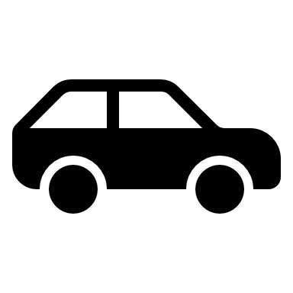**Automobile Incident:**

|  |  |
| --- | --- |
| Date of Incident? |  |
| Were you at fault? | **YES - NO** |
| Were you cited for a violation? | **YES - NO** |
| Was your vehicle moving or sitting? | **MOVING - SITTING** |
| Did you or your party suffer any significant injuries? | **YES - NO** |
| Were any other vehicles or property damaged? | **YES - NO** |
| Total Cost of damages/injuries? |  |

**Description of incident:**

________________________________________________________________________________________________________________________________________________________________________________________________________________________________________________________________________________________________________________________________________________________________________________________________________________________________________________________________________________________________________________________________________________________

* To help the community service your request, please provide any applicable documentation such as receipts or pictures and attach to this form.

**How did your insurance company pay?**

|  |  |
| --- | --- |
| * My insurance covered my claim in full | * My insurance covered all except the applicable deductibles |
| * My insurance covered up to its policy limits | * My insurance did not cover at all |
| * The other party’s insurance covered my damages in full | * The other party’s insurance covered a portion of my damages |
| * I do not have insurance | * Other – describe below |

_________________________________________________________________________________________________________________________________________________________________________________________________________

**What kind of benefit payout are you requesting?**

* I am requesting withdrawal of the full benefits available
* I am requesting a partial withdrawal of benefits - ________ UMC